Hinckley Public Library District
Board of Trustees Special Meeting Minutes
September 29, 2025

At 6:31 pm, Board President Karen Yaggie called the meeting to order.

Trustees present: Tom Lang, Fran Kriesch, Pam Keown, and Amie Carey.
Trustee absent: Carol Kohler.

Comments from the Public
There were no comments.
Unfinished Business
Construction Budget and Funding Approval: John Shales and Josh Campanelli from SMC Construction Services as well as Andy Ouper from Williams Architects were present to answer questions and inform the board of updates on the building project since the last meeting. The second round of bidding produced a lower bid for the windows but a much higher price on excavation. Working to get the total project cost down to the library’s available funding, painting and signage were removed and the furniture budget was lowered. Though the number that was reached is still approximately $90,000 more than the existing funding, the difference can be made up with more fundraising, grants, and loans if needed. Amie made a motion to accept the construction budget as presented for a total of $2,536,965. Fran seconded the motion. It passed unanimously on a roll call vote.
Award Bids for West Lincoln Building Project: SMC confirmed the qualified low bidders for the ten different trades and provided a recommendation of award for the board: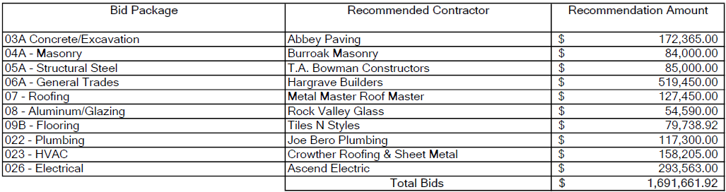
A painting bid will not be accepted at this time due to budget constraints. Amie made a motion to award the bids for the West Lincoln Building Project as included in the recommendation. Pam seconded the motion. It passed unanimously on a roll call vote.
New Business
Approval of Trade Contracts for Building Project: No information was available for this topic.
Trustee Vacancy: Arlen Carls moved out of the library service area, so he is no longer eligible to serve on the board. The board discussed a potential replacement but made no decision.
The meeting adjourned at 7:10 pm.

